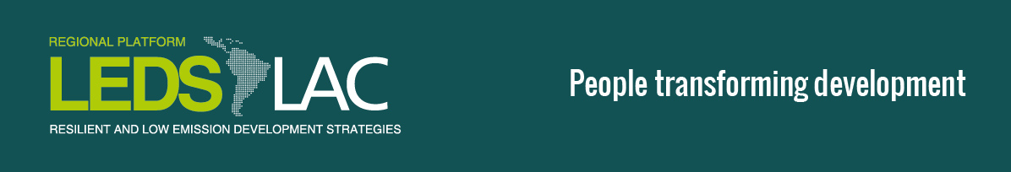

V Regional LEDS LAC Workshop
Call for Proposals for Training Sessions

The Regional Platform for Latin America and the Caribbean (LEDS LAC) of the Low Emission Development Strategies Global Partnership (LEDS GP) is a community of practice that brings together leaders in the area of low emission and climate resilient development in the region.
The V Regional LEDS LAC Workshop will take place on the 26, 27 and 28th of September 2016, in Panama City, Panama. The workshop will focus on the implementation of Paris Agreement to move towards a resilient and low emission development in the region.
LEDS LAC Platform is inviting applications for training sessions during the workshop. Interested organizations are requested to submit their applications through a short proposal note in the prescribed format below. We currently have space in the agenda for three concurrent training sessions of 3 hours each, on the morning of Wednesday September 28th.
Proposals should be sent by July 15 to María José Gutiérrez from the LEDS LAC Secretariat at the e-mail address: mariajose.gutierrez@ledslac.org.

Criteria for the sessions:
- The activities of the session must be focused on building capacities to apply concepts, methodologies and tools for planning and/or implementing low emission climate resilient development strategies.
- They should be related to one or more of the Platform´s priorities: integration of mitigation and adaptation agendas in climate policies; articulation of sectorial efforts and different government levels for an urban resilient and low emissions development; articulation or sectorial efforts for a rural resilient and low emissions development; involvement of the private sector in LEDS; developing financial and economic instruments to promote LEDS; technological transfer; and MRV.
- The sessions should be as dynamic as possible, using simulations, role-playing exercises, getting participants to apply a tool with a real world data set, etc.
- Ideally, the institution organizing the session should cover travel expenses for their team and invited presenters/instructor.
- Sessions can be either in Spanish or English. Simultaneous translation can be made available in all break-out rooms.
- Training sessions must be no longer than 3 hours.

1. Organization

2. Topic of the Training Session

3. Brief description of the objectives and the methodology to be used in the session

4. Preliminary structure (activities and time distribution) - total time must be ideally of 3 hours

5. If possible, indicate potential speakers and/or instructors

